CHAPTER 1

INTRODUCTION

1.1 General:
A humanoid robot is a robot with its body shape built to resemble the human body. The design may be for functional purposes, such as interacting with human tools and environments, for experimental purposes, such as the study of bipedal locomotion (Bipedalism is a form of terrestrial locomotion where an organism moves by means of its two rear limbs or legs. An animal or machine that usually moves in a bipedal manner is known as a biped), or for other purposes. In general, humanoid robots have a torso, a head, two arms, and two legs, though some forms of humanoid robots may model only part of the body, for example, from the waist up. Some humanoid robots also have heads designed to replicate human facial features such as eyes and mouths. Androids (An android is a humanoid robot or synthetic organism designed to look and act like a human, especially one with a body having a flesh-like resemblance) are humanoid robots built to aesthetically resemble humans.
The development of a humanoid robot in the collaborative research Centre 588 has the objective of creating a machine that closely cooperates with humans. The collaborative research centre 588 (SFB588) “Humanoid Robots – learning and cooperating multi-modal robots” was established by the German Research Foundation (DFG) in Karlsruhe in May 2000. The SFB588 is a cooperation of the University of Karlsruhe, the Forschungs zentrum Karlsruhe (FZK), the Research Center for Information Technologies (FZI) and the Fraunhofer Institute for Information and Data Processing (IITB) in Karlsruhe.
In this project, scientists from different academic fields develop concepts, methods and concrete mechatronic components and integrate them into a humanoid robot that can share its working space with humans. The long-term target is the interactive cooperation of robots and humans in complex environments and situations. For communication with the robot, humans should be able to use natural communication channels like speech, touch or gestures. The demonstration scenario chosen in this project is a household robot for various tasks in the kitchen.
Humanoid robots are still a young technology with many research challenges. Only few humanoid robots are currently commercially available, often at high costs. Physical prototypes of robots are needed to investigate the complex interactions between robots and humans and to integrate and validate research results from the different research fields involved in humanoid robotics. The development of a humanoid robot platform according to a special target system at the beginning of a research project is often considered a time consuming hindrance. In this article a process for the efficient design of humanoid robot systems is presented. The goal of this process is to minimize the development time for new humanoid robot platforms by including the experience and knowledge gained in the development of humanoid robot components in the collaborative research centre 588.
Weight and stiffness of robot components have a significant influence on energy efficiency, operating time, safety for users and the dynamic behavior of the system in general. The finite element based method of topology optimization gives designers the possibility to develop structural components efficiently according to specified loads and boundary conditions without having to rely on coarse calculations, experience or intuition. The design of the central support structure of the upper body of the humanoid robot ARMAR III is an example for how topology optimization can be applied in humanoid robotics. Finally the design of the upper body of the humanoid ARMAR III is presented in detail.

1.2 Purpose:
Humanoid robots are now used as a research tool in several scientific areas.
Researchers need to understand the human body structure and behaviour (biomechanics) to build and study humanoid robots. On the other side, the attempt to the simulation of the human body leads to a better understanding of it. Human cognition is a field of study which is focused on how humans learn from sensory information in order to acquire perceptual and motor skills. This knowledge is used to develop computational models of human behaviour and it has been improving over time.
Although the initial aim of humanoid research was to build better orthotics and prosthesis for human beings, knowledge has been transferred between both disciplines. A few examples are: powered leg prosthesis for neuromuscular impaired, ankle-foot orthotics, biological realistic leg prosthesis and forearm prosthesis.
Besides the research, humanoid robots are being developed to perform human tasks like personal assistance, where they should be able to assist the sick and elderly, and dirty or dangerous jobs. Regular jobs like being a receptionist or a worker of an automotive manufacturing line are also suitable for humanoids. They are becoming increasingly popular for providing entertainment too. For example, Ursula, a female robot, sings, play music, dances, and speaks to her audiences at Universal Studios. Several Disney attractions employ the use of animations, robots that look, move, and speak much like human beings, in some of their theme park shows. These animations look so realistic that it can be hard to decipher from a distance whether or not they are actually human. Although they have a realistic look, they have no cognition or physical autonomy. Humanoid robots, especially with artificial intelligence algorithms, could be useful for future dangerous and/or distant space exploration missions, without having the need to turn back around again and return to Earth once the mission is completed.

1.3 Introduction of ALUMINA (ALUMINOID):
This robot is a professional small humanoid robot consist of full aluminum parts, smooth surface with smooth edges not hurting hands, the metal is unbleached, beautiful and durable.
The High Torque Standard Servo Motor with Dual Ball Bearing and Metal Gears. Provides 14kg/cm at 4.8V and 16kg/cm at 6V. Replacement for HS-645MG.
Arduino Uno R3 based USB 18 Servo Controller is ideal for making Autonomous and PC based systems which run over Hobby Servo motors. The software helps to develop the complex sequences in real time on the hardware like robotic arms, walkers, bipeds and any other servo controlled system. It also generates Arduino based code for the developed sequence which can be deployed on the controller on board thereby making the robot autonomous.
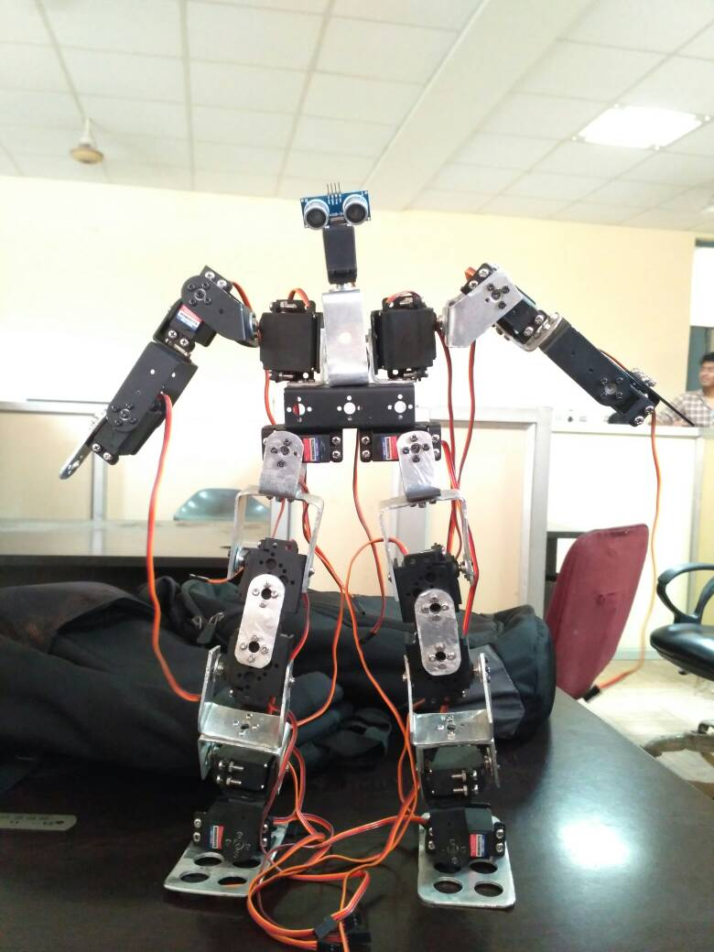
Fig: - 1.1 (Alumina )

1.4 Literature Overview:

- Lie Zi described about automation 250BC on which Robots works.
- Greek mathematician Hero of Alexandria described a machine to automatically pour wine for party guests in 50AD.
- Al-Jazari described a band made up of humanoid automata in 1206.
- Leonardo da Vinci designs a humanoid automaton that looks like an armoured knight, known as Leonardo's robot in 1495.
- Isaac Asimov formulates the Three Laws of Robotics, used in his robot science fiction storiess in 1941 – 42.
- Honda developed P1 (Prototype Model 1) through P3, an evolution from E series, with upper limbs in 1993.
- Honda creates its 11th bipedal humanoid robot, able to run ASIMO in 2000 and further amendments were done till now.
- iCub, a biped humanoid open source robot for cognition research 2006 (it is actually a spoiled baby having height 100cm & Weight 23kg).

1.5 Laws of Humanoid Robot:
- Zeroth Law: - “A Robot must not injure humanity although in action, allow humanity come to harm”.
- First Law: - “A Robot must not harm a human body although in action, allow one to come to harm”.
- Second Law: - “A Robot must always obey human being, unless it is in conflict with a higher order law”.
- Third Law: - “A Robot must protect itself from harm unless that it is conflict with a higher order law”.

1.6 Demand for efficient design of humanoid robots:
Industrial robots are being used in many manufacturing plants all over the world. This
Product class has reached a high level of maturity and a broad variety of robots for special
Applications is available from different manufacturers. Even though both kind of robots, industrial and humanoid, manipulate objects and the same types of components, e.g. harmonic drive gears, can be found in both types, the target systems differ significantly.
Industrial robots operate in secluded environments strictly separated from humans. They perform a limited number of clearly defined repetitive tasks. These machines and the tools they use are often designed for a special purpose. High accuracy, high payload, high velocities and stiffness are typical development goals.
Humanoid robots work together in a shared space with humans. They are designed as universal helpers and should be able to learn new skills and to apply them to new, previously unknown tasks. Humanlike kinematics allows the robot to act in an environment originally designed for humans and to use the same tools as humans in a similar way. Human appearance, behavior and motions which are familiar to the user from interaction with peers make humanoid robots more predictable and increase their acceptance. Safety for the user is a critical requirement. Besides energy efficient drive technology, a lightweight design is important not only for the mobility of the system but also for the safety of the user as a heavy robot arm will probably cause more harm in case of an accident than a light and more compliant one. Due to these significant differences, much of the development knowledge and product knowledge from industrial robots cannot be applied to humanoid robots.
The multi-modal interaction between a humanoid robot and its environment, the human users and eventually other humanoids cannot fully be simulated in its entire complexity. To investigate these coherences, actual humanoid robots and experiments are needed. Currently only toy robots and a few research platforms are commercially available, often at high cost. Most humanoid robots are designed and built according to the special focus or goals of a particular research project and many more will be built before mature and standardized robots will be available in larger numbers at lower prizes. Knowledge gained from the development of industrial robots that have been used in industrial production applications for decades cannot simply be reused in the design of humanoid robots due to significant differences in the target systems for both product classes. A few humanoid robots have been developed by companies, but not much is known about their design process and seldom is there any information available that can be used for increasing the time and cost efficiency in the development of new improved humanoid robots. Designing a humanoid robot is a long and iterative process as there are various interactions between e.g. mechanical parts and the control system. The goal of this article is to help shortening the development time and to reduce the number of iterations by presenting a process for efficient design, a method for optimizing light yet stiff support structures and presenting the design of the upper body of the humanoid robot ARMAR III.
1.7 Design process for humanoid robot modules:
The final goal of the development of humanoid robots is to reproduce the capabilities of a human being in a technical system. Even though several humanoid robots already exist and significant effort is put into this research field, we are still very far from reaching this goal.
Humanoid robots are complex systems which are characterized by high functional and spatial integration. The design of such systems is a challenge for designers which cannot yet be satisfactorily solved and which is often a long and iterative process. Mechatronic systems like humanoid robots feature multi-technological interactions, which are displayed by the existing development processes, e.g. in the VDI guideline 2206 “design methodology for mechatronics systems” (VDI 2004), in a rather general and therefore abstract way.
More specific development processes help to increase the efficiency of the system development. Humanoid robots are a good example for complex and highly integrated systems with spatial and functional interconnections between components and assembly groups. They are multi-body systems in which mechanical, electronic, and information-technological components are integrated into a small design space and designed to interact with each other.
1.8 Requirements:
The demands result from the actions that the humanoid robot is supposed to perform. The robot designed in the SFB 588 will interact with humans in their homes, especially in the kitchen. It will take over tasks from humans, for example loading a dish washer. For this task it is not necessary, that the robot can walk on two legs, but it has to feature kinematics, especially in the arms, that enable it to reach for objects in the human surrounding. In addition, the robot needs the ability to move and to hold objects in its hand (Schulz, 2003).
1.9 Subdivision of the total system:
The development of complex systems requires a subdivision of the total system into manageable partial systems and modules (Fig. 1). The segmentation of the total system of the humanoid robot is oriented on the interactions present in a system. The total system can be divided into several subsystems. The relations inside the subsystems are stronger compared to the interactions between these subsystems. One partial system of the humanoid robot is e.g. the upper body with the subsystem arm. The elements in the lowest level in the hierarchy of subsystems are here referred to as modules. In the humanoid robot’s arm, these modules are hand-, elbow-, and shoulder joint. Under consideration of the remaining design, these modules can be exchanged with other modules that fulfil the same function. The modules again consist of function units, as e.g. the actuators for one of the module’s joints. The function units themselves consist of components, here regarded as the smallest elements. In the entire drive, these components are the actuator providing the drive power and the components in the drive train connected in a serial arrangement, e.g. gears, drive belt, or worm gear transferring the drive power to the joint.
1.10 Selection and data base:
Many components used in such highly integrated systems are commonly known, commercially available and do not have to be newly invented. However, a humanoid robot consists of a large number of components, and for each of them there may be a variety of technical solutions. This leads to an overwhelming number of possible combinations, which cannot easily be overseen without help and which complicates an efficient target-oriented development. Therefore it is helpful to file the components of the joints, actuators and sensors as objects in an object-oriented classification. It enables a requirement-specific access to the objects and delivers information about possible combinations of components.

1.11 Development sequence:
The development sequence conforms to the order in which a component or information has to be provided for the further procedure. The development process can be roughly divided into two main sections. The first section determines the basic requirements for the total system, which have to be known before the design process. This phase includes primarily two iterations: In the first iteration, the kinematics of the robot is specified according to the motion space of the robot and the kinematics again has to be describable in order to be controllable. In the second iteration, the control concept for the robot and the general possibilities for operating the joints are adjusted to the requirements for the desired dynamics of the robots. The second sector is the actual design process.
The sequence in which the modules are developed is determined by their position in the serial kinematics of the robot. This means that e.g. in the arm, first the wrist, the elbow joint and then finally the shoulder joint are designed.
Since generally all modules have a similar design structure, they can be designed according to the same procedure. The sequence in this procedure model is determined by the interactions between the function units and between the components. The relation between the components and the behavior of their interaction in case of a change of the development order can be displayed graphically in a design structure matrix (Browning, 2001). Iterations, which always occur in the development of complex systems, can be limited by early considering the properties of the components that are integrated at the end of the development process. One example is the torque measurement in the drive train.
In the aforementioned data base, specifications of the components are given like the possibility for a component of the drive train to include some kind of torque measurement. It ensures that after the assembly of a drive train, a power measurement can be integrated.
1.12 Development of a shoulder joint:
The development of a robot shoulder joint according to this approach is exemplarily described in the following paragraphs. For the tasks that are required from the robot, it is sufficient if the robot is able to move the arm in front of its body. These movements can be performed by means of a ball joint in the shoulder without an additional pectoral girdle. In the available design space, a ball joint can be modelled with the required performance of the actuators and sensors as a serial connection of three single joints. The axes of rotation of these joints intersect at one point. A replacement joint is used which consists of a roll joint, a pitch joint, and then again of another roll joint. The description of the kinematics can only be clarified together with the entire arm, which requires limiting measures, especially if redundant degrees of freedom exist (Asfour, 2003).
Information about the mass of the arm and its distribution are requirements for the design of the shoulder joint module. In addition, information about the connection of elbow and shoulder has to be available. This includes the components that are led from the elbow to or through the shoulder, as e.g. cables or drive trains of lower joints. The entire mechatronic system can be described in an abstract way by the object-oriented means of SysML (System
Modelling Language) (SysML, 2005) diagrams, with which it is possible to perform a system test with regard to compatibility and operational reliability. It enables the representation of complex systems at different abstraction levels. Components that are combined in this way can be accessed in the aforementioned classification, which facilitates a quick selection of the components that can be used for the system. In addition, it makes a function design model possible at every point of the development.
In the development of the shoulder module, at first the function units of the joints for the three rotating axes are selected according to the kinematics. Then, the function unit drive, including the actuators and the drive trains, are integrated. Hereafter, the sensors are selected and integrated. In order to prevent time consuming iterations in the development, 6 Humanoid Robots, New Developments the components of the total system, integrated at a later stage, are already considered from the start with regard to their general requirements for being integrated. Examples for this are the sensors, which can then be assembled without problems since it is made sure that the already designed system offers the possibility to integrate them. During the next step the neighboring module is designed. Information about the required interface of the shoulder and the mass of the arm and its distribution are given to the torso module.

